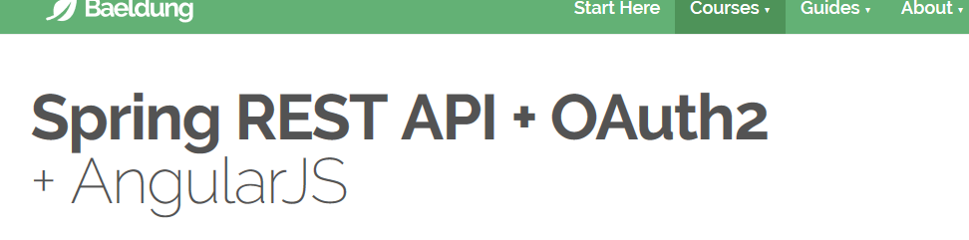

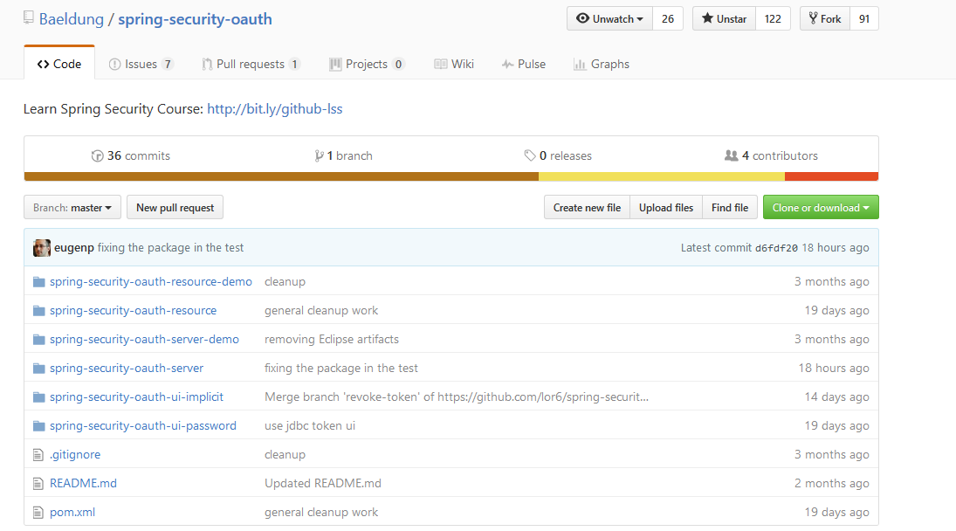

<http://www.baeldung.com/rest-api-spring-oauth2-angularjs>

<https://github.com/Baeldung/spring-security-oauth/tree/master/spring-security-oauth-server/src>

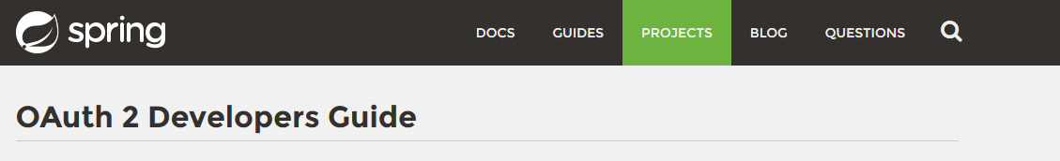

<http://projects.spring.io/spring-security-oauth/docs/oauth2.html>

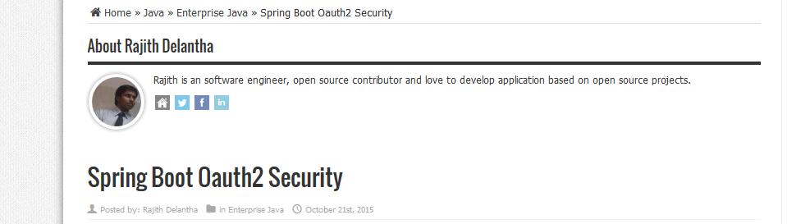

<https://www.javacodegeeks.com/2015/10/spring-boot-oauth2-security.html>

<https://www.javacodegeeks.com/2015/10/spring-boot-oauth2-security.html>

<https://github.com/rajithd/spring-boot-oauth2>

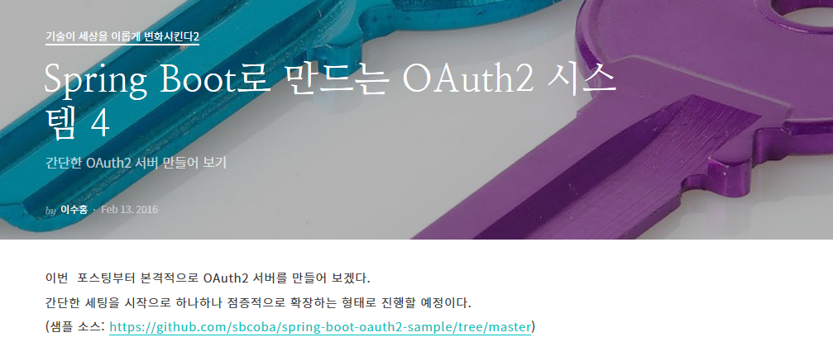

https://brunch.co.kr/@sbcoba/4

조대협

[http://jekalmin.tistory.com/entry/spring-bootoauth-%EC%84%B8%ED%8C%85-%ED%85%8C%EC%8A%A4%ED%8A%B8](http://jekalmin.tistory.com/entry/spring-bootoauth-세팅-테스트)

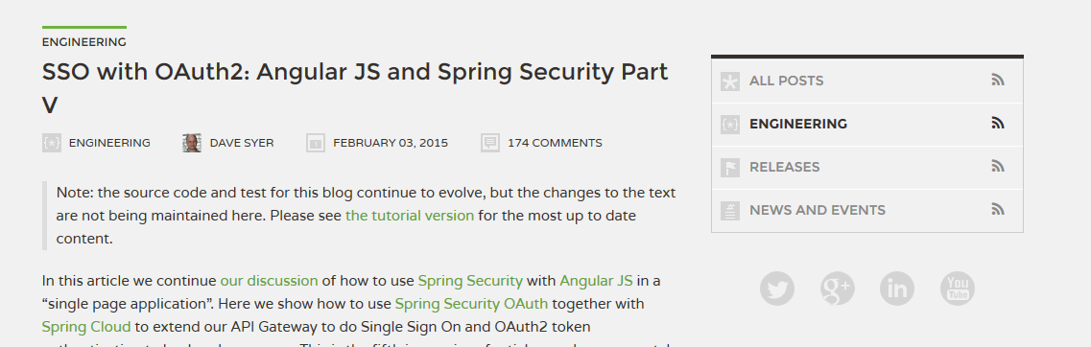

<https://spring.io/blog/2015/02/03/sso-with-oauth2-angular-js-and-spring-security-part-v>

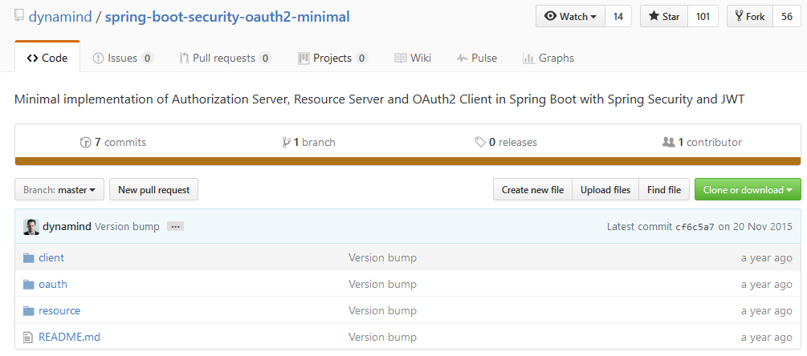

<https://github.com/dynamind/spring-boot-security-oauth2-minimal>

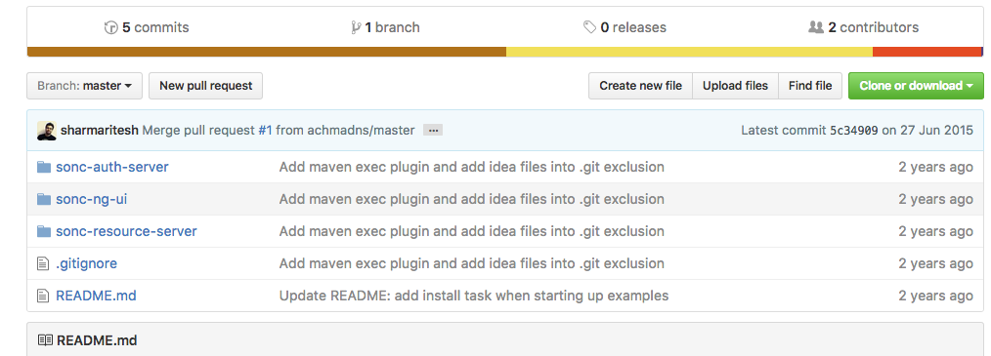

<https://github.com/sharmaritesh/spring-angularjs-oauth2-sample>

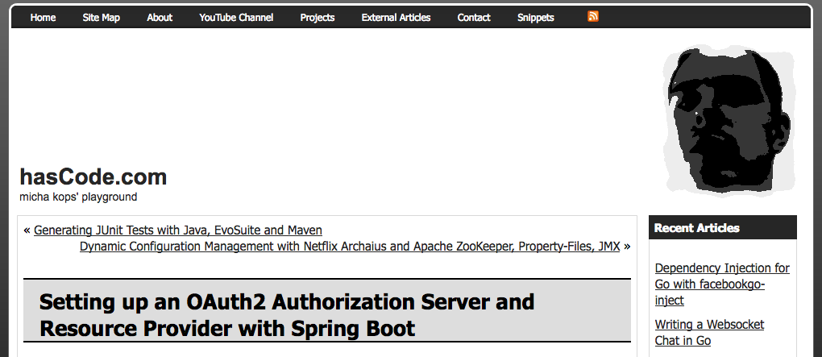

<http://www.hascode.com/2016/03/setting-up-an-oauth2-authorization-server-and-resource-provider-with-spring-boot/>

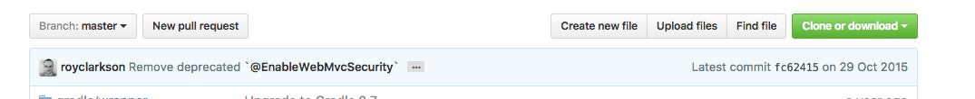

<https://github.com/royclarkson/spring-rest-service-oauth>

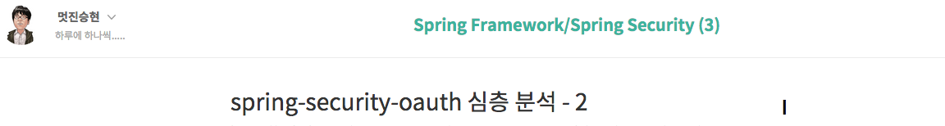

http://kimseunghyun76.tistory.com/404

**[Spring Boot]Rest with Spring Security OAuth2 Authentication using Mysql (진행중) http://m.blog.naver.com/wizardkyn/220650609325**

1. 참조 URL

OAuth2 기본 개념

<https://developers.daum.net/services/apis/docs/oauth2_0/reference>

개발자 가이드 및 샘플 소스

<http://projects.spring.io/spring-security-oauth/docs/oauth2.html>  
<https://github.com/spring-projects/spring-security-oauth/tree/master/samples>  
<https://github.com/spring-projects/spring-security-oauth/tree/master/tests/annotation/jdbc>  
<https://brunch.co.kr/@sbcoba/4>

<http://www.baeldung.com/rest-api-spring-oauth2-angularjs>  
<https://www.javacodegeeks.com/2015/10/spring-boot-oauth2-security.html>

H2 SQL Scheme

<https://github.com/spring-projects/spring-security-oauth/blob/master/spring-security-oauth2/src/test/resources/schema.sql>

Jwt secre 서명

<https://github.com/dynamind/spring-boot-security-oauth2-minimal.git>

